PWM Signal Generation by Using AVR Timers.

In this tutorial we will set up the TIMER0 in fast pwm mode and use it to generate PWM signals of varying duty cycles. In this way we would be generating analog signals of voltages between 0 and 5v. In the example we will connect this output to a LED and see how it varies its brightness. Please see the previous tutorials on PWM and TIMERs before reading this tutorial.
PWM
- Introduction to PWM - Pulse Width Modulation
- PWM Signal Generation with AVR Timers.
Timers
- Introduction To AVR Timers.
- Timers In Compare Mode Part I
- Timers In Compare Mode Part II
Setting Up TIMER0 in Fast PWM mode

Setting up the TIMER0 in fast pwm mode is very easy and just require one line of code. You only need to deal with one register named TCCR0 (Timer Counter Control Register For Timer 0). You just need to set up various bits in it to get the required setting. The various bits of TCCR0 is given below.
TCCR0
This register is used for configuring the TIMER0. See Timer Tutorial for more info. The explanation of various bits of this register is as follows.
PWM
- Introduction to PWM - Pulse Width Modulation
- PWM Signal Generation with AVR Timers.

Timers
- Introduction To AVR Timers.
- Timers In Compare Mode Part I
- Timers In Compare Mode Part II
Setting Up TIMER0 in Fast PWM mode:
Setting up the TIMER0 in fast pwm mode is very easy and just require one line of code. You only need to deal with one register named TCCR0 (Timer Counter Control Register For Timer 0). You just need to set up various bits in it to get the required setting. The various bits of TCCR0 is given below.
TCCR0:

This register is used for configuring the TIMER0. See Timer Tutorial for more info. The explanation of various bits of this register is as follows.
In the last tutorial you saw how the PWM technique helps us generate analog signals from a microcontroller. In this tutorial we will see how PWM generation is implemented with microcontrollers.
Before you begin please see
- Introduction to PWM
- Introduction to AVR Timers
Generation of PWM signals is such a common need that all modern microcontrollers like AVR has dedicated hardware for that. The dedicated hardware eliminates the load of generation of PWM signal from software (thus frees the CPU ). Its like asking the hardware to generate a PWM signal of a specific duty cycle and the task of CPU is over. The PWM hardware with start delivering the required signal from one of its PINs while the CPU can continue with other tasks.
In AVR microcontrollers PWM signals are generated by the TIMER units. (See AVR Timer Tutorials) . In this tutorial I will give you the basic idea of how PWM signals are generated by AVR timers. Their are two methods by which you can generate PWM from AVR TIMER0 (for ATmega16 and ATmega32 MCUs).
- Fast PWM
- Phase Correct PWM
Don't worry from their names they will become clear to you as we go on. First we will be considering the Fast PWM mode.
PWM Generation Fundas:
We will use the simplest timer, TIMER0 for PWM generation.(Note TIMER0 of ATmega8 cannot be used for PWM generation, these are valid for ATmega16 and ATmega32). In this part we won't be dealing with any code, we would just analyze the concepts. So lets start. We have a 8bit counter counting from 0-255 and the goes to 0 and so on. This can be shown on graph as

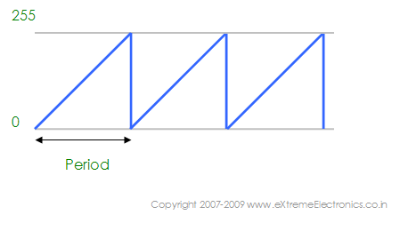

The period depends upon the presale settings. Now for PWM generation from this count sequence we have a new "friend" named OCR0 (Output Compare Register Zero , zero because its for TIMER0 and there are more of these for TIMER1 & TIMER2). We can store any value between 0-255 in OCR0, say we store 64 in OCR0 then it would appear in the graph as follows (the RED line).

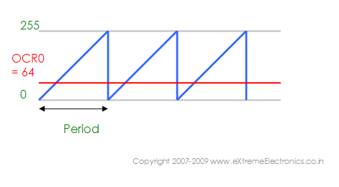
An IR range finder which can effectively suppress the influence of direct transmission waves is provided. An IR range finder according to the present invention comprises a transmitting IR sensor, a receiving IR sensor. IR sensor will find the obstacle distance and LCD will show the distance in cm. Based on the obstacle distance AVR microcontroller will automatically control the speed of the motors. If obstacle reaching very near to us it will automatically give the buzzer and speed of the motors will gradually decreasing and automatically stop. After clearance again motors will run with high speed.
This is shown in the figure 3. This PIN is named OC0 and you can find it in the PIN configuration of ATmeg
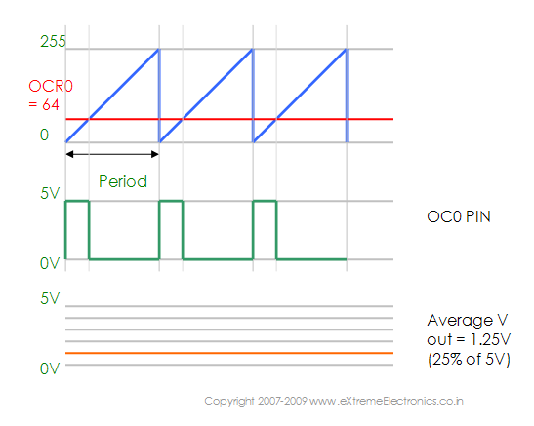
a32.
From the figure you can see that a wave of duty cycle of 64/256 = 25% is produced by setting OCR0=64. You can set OCR0 to any value and get a PWM of duty cycle of (OCR0 / 256). When you set it to 0 you get 0% dutycycle while setting it to 255 you get 100% duty cycle output. Thus by varying duty cycle you can get an analog voltage output from the OC0 PIN. The resolution of this PWM is 8BIT. Watch the animation below for a step by step explanation of PWM generation process.
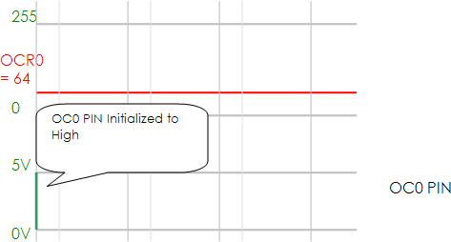

One note about OCR0 is that it is double buffered. But what does than means?
It is just for your help. Double buffering means that you cannot directly write to OCR0 when ever you write to OCR0 you are actually writing to a buffer. The value of buffer is copied to actual OCR0 only during start of cycle (when TCNT0 wraps from 255 to 0). This nice feature prevents update of OCR0 in between the cycles. The new value of OCR0 comes into effect only on beginning of a new cycle even if you write to it in between a cycle.
In next tutorial we will see how to setup the TIMER0 in fast PWM mode, actually generate some PWM signals and use this to control the brightness of a LED.
A digital device like a microcontroller can easily work with inputs and outputs that has only two state, on and off. So you can easily use it to control a LED's state i.e. on or off. In the same way you can use it to control any electrical device on/off by using proper drivers (transistor,triac, relays etc). But sometimes you need more than just "on" & "off " control over the device. Like if you wanna control the brightness of a LED (or any lamp) or the speed of DC motor then digital (on/off) signals simply can't do it. This situation is very smartly handled by a technique called PWM or Pulse Width Modulation.
PWM is the technique used to generate analogue signals from a digital device like a MCU. Almost all modern MCUs have dedicated hardware for PWM signal generation. In this tutorial we will learn the basics of PWM technique and later on we will see how to implement PWM generation with AVR microcontrollers.
PWM : Pulse Width Modulation:
A digital device, like a microcontroller can only generate two levels on its output lines, HIGH=5v and LOW=0V. But what if we want to generate 2.5v or 3.1v or any voltage between 0-5 volt output ? For these kinds of requirement, instead of generating a constant DC voltage output we generate a square wave, which has high = 5V and Low = 0v (See figure 1).
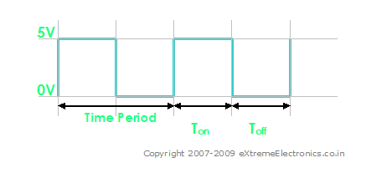

A PWM Waveform

In the figure you can see a PWM signal. As you can see it is just a digital signal (can easily be generated by MCUs). But let me clarify some of its properties.
- The signal remains "ON" for some time and "OFF" for some time.
- Ton = Time the output remains high.
- Toff = Time the output remains Low.
- When output is high the voltage is 5v'
- When output is low the voltage is 0v
- T = Time Period = Ton + Toff

Duty Cycle:
It is defined by
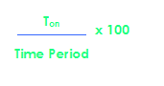
So you can see it is just the percentage of the total time the output was high. In the above figure (Fig. 1) you can see that Ton = Toff = Half of the time period. So the duty cycle is 50%. If the frequency of such wave is sufficiently high (say 500 Hz) the output you get is half of 5v i.e. 2.5 volts. Thus if this output is connected to a motor(by means of suitable drivers) it will run at 50% of its full speed at 5v. The PWM technique utilizes this fact to generate any voltage between two extremes (for example between 0-12volts). The trick is to vary the duty cycle between 0-100% and get same percentage of input voltage to output. Below are some examples of PWM signals of different duty cycle.
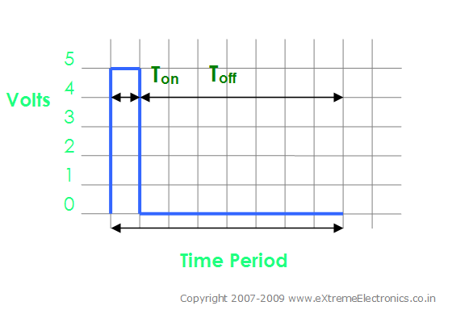
A PWM Waveform. Duty Cycle = 12.5% Analog Voltage Out = 12.5% of Vcc (5v) = 0.625 Volts

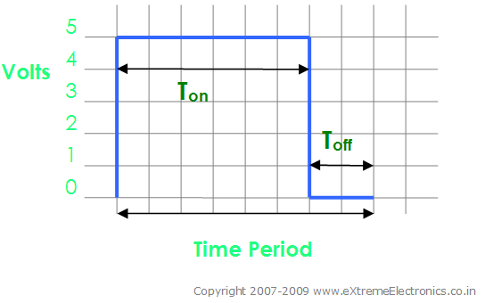
A PWM Waveform. Duty Cycle = 75% Analog Voltage Out = 75% of Vcc (5v) = 3.75 Volts
So you just saw how we can generate analog voltage levels from a digital system using PWM technique. If the output is provided with an R/C filter you will get a pure DC signals levels instead of square waves. But this isn't required for driving motors or controlling LED's brightness. You can feed the PWM signals directly to then (by directly I mean without the R/C filter and not the drivers (like transistor etc)).
In the next tutorial we will see how to actually generate PWM signals from an AVR MCU. Till then good bye. But don't forget to leave your comment ! May be you have some doubts, request or any feedback, feel free to say !

